Sales Data Cleaning & Analysis Report
Online retail orders, January - December 2025
Sample project. The dataset is synthetic (computer-generated) and was built to contain realistic data problems. No real customer, business or figure is described here.

1. Summary
The raw export had 4,240 rows and could not be trusted as it stood: duplicated orders, three date formats, impossible quantities and prices, and gaps in nearly every column. After cleaning, 3,992 validated orders remain, and every one reconciles (quantity x price x (1 - discount) = total). The analysis then shows:
- Revenue: net revenue (delivered orders) was EGP 10.19M from 3,366 orders, an average order value of EGP 3,027.
- Seasonality: November was the peak month at EGP 1,202K, 47% above the average of the other months. March was second at EGP 1,054K.
- Concentration: two products (Smartphone and Treadmill) bring 37% of net revenue out of 23 products. Cairo, Alexandria and Giza bring 67%.
- Returns: Fashion has a 14.9% return rate against 7.9% overall, and generates 42% of all returned orders from 13% of revenue.
- Discounts: deeper discounts raise units per order (1.35 at 0% to 1.82 at 25%) but not order value (EGP 3,023 vs EGP 2,849), so they are not paying for themselves.

2. Data cleaning
Every issue was measured before it was fixed, and every fix is recorded in the Cleaning_Log sheet of the workbook. Rows that were removed are kept in Removed_Records with the reason.
Issue found | Rows | Treatment
Duplicate orders (exact and near-duplicates) | 240 | Removed, first occurrence kept
Missing order date | 8 | Removed and listed (date cannot be guessed)
Three date formats in one column | 1,595 | Converted to one real date type
City spelled many ways (cairo, CAIRO, Cario, Alex) | 848 | One canonical name per city
Category spelling variants | 437 | 5 canonical categories
Payment method written many ways | 2,490 | 5 canonical methods
Order status variants (Canceled / Cancelled ...) | 2,591 | 4 canonical statuses
Order totals stored as text ('EGP 1,008.00') | 1,639 | Converted to numbers
Discount as 0.10 in some rows and 10 in others | 209 | One percent scale
Impossible quantities (up to 999 units) | 13 | Rebuilt from the order total
Negative or x100 unit prices | 12 | Rebuilt from the order total
Missing quantity / unit price / total | 280 | Rebuilt from the other fields on the same order
Missing customer name / city | 280 | Filled from the same customer's other orders
Missing payment method | 199 | Labelled 'Unknown' (not guessed)

Method
- Rebuild before guess. A missing or impossible number is first recalculated from the other fields of the same order. Only if that is impossible is the product median used.
- Never invent text. A missing city or name is filled from the same customer's other orders; otherwise it is labelled 'Unknown'. Missing payment methods stay 'Unknown'.
- Outliers by rule, not by eye. Quantities above 20 or below 1, and prices below half or above double the product median, were flagged (an IQR fence on quantity gave the same cases). 301 rows carry a note in the dq_flag column showing what was repaired.

Validation
Because this sample is synthetic, the cleaned values could be compared with the original uncorrupted data. Dates, categories, cities, names, statuses and quantities matched on 100% of rows; unit price and order total matched on 99.97%. The few remaining differences come from 4 orders where the total and another number were missing at the same time, so only a product median was available; total revenue differs from the original by 0.0013%. On real data this check is replaced by reconciliation against the client's own totals.

3. Key indicators
KPI | Value | KPI | Value
Net revenue (delivered) | EGP 10,187,702 | Return rate | 7.9%
Gross order value (excl. cancelled) | EGP 11,070,322 | Cancellation rate | 6.5%
Total orders | 3,992 | Unique customers | 877
Delivered orders | 3,366 | Orders per customer | 4.55
Average order value | EGP 3,027 | Average discount | 8.2%
Units sold (delivered) | 5,027 | Pending orders | 77
Net revenue counts delivered orders only. Returned and cancelled orders are excluded, and pending orders (placed from 18 December) are not yet revenue.

4. Findings

Trend over time
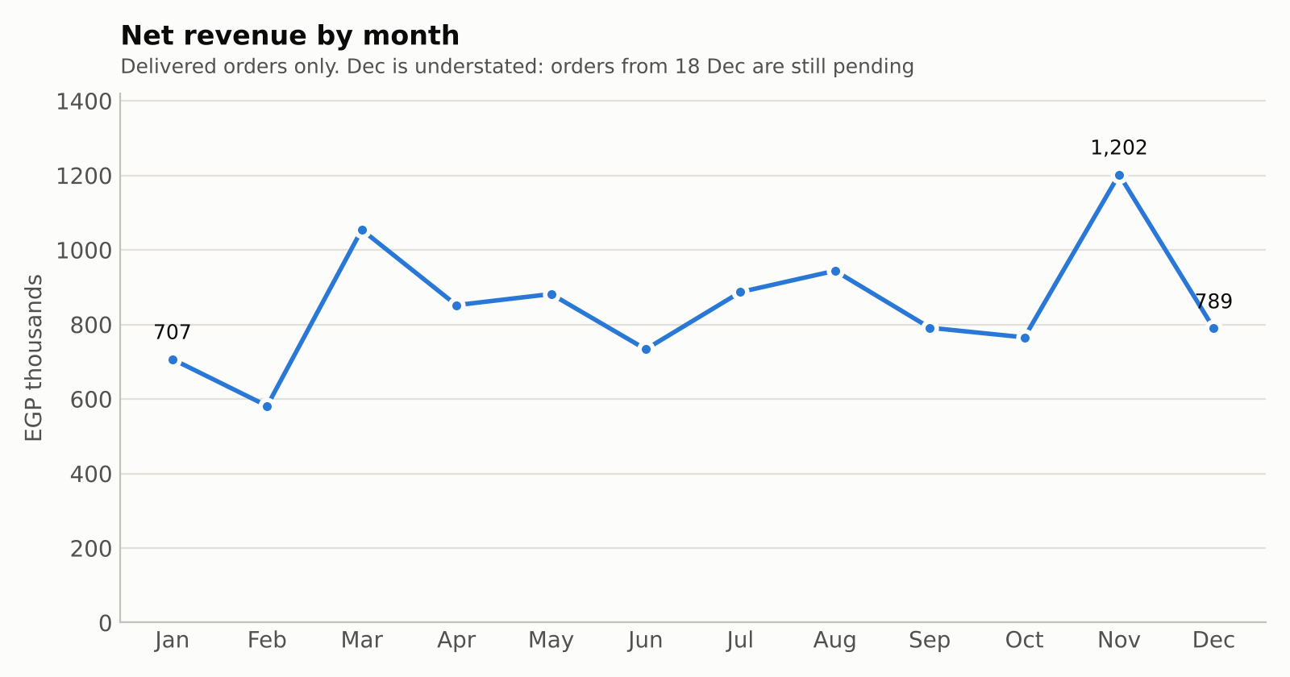
November (Black Friday season) reached EGP 1,202K, 47% above the average of the other months, on the highest order count of the year (433 delivered). December looks weak only because 77 orders from the last two weeks were still pending when the data was exported.

Categories and returns
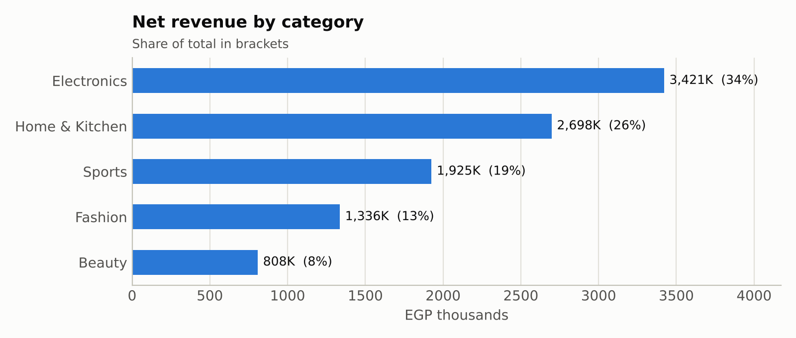
Electronics leads with 34% of net revenue, followed by Home & Kitchen (26%). Fashion sells many orders (905) but at low value, so it is only 13% of revenue.
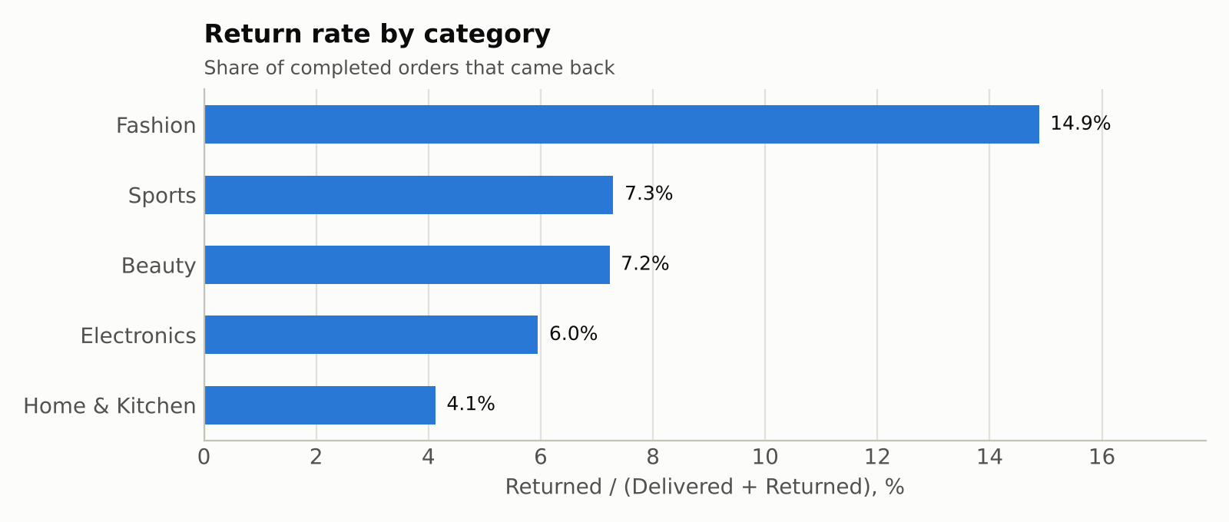
The Fashion return rate is at least twice that of any other category. Home & Kitchen is the most reliable at 4.1%.

Geography and payment
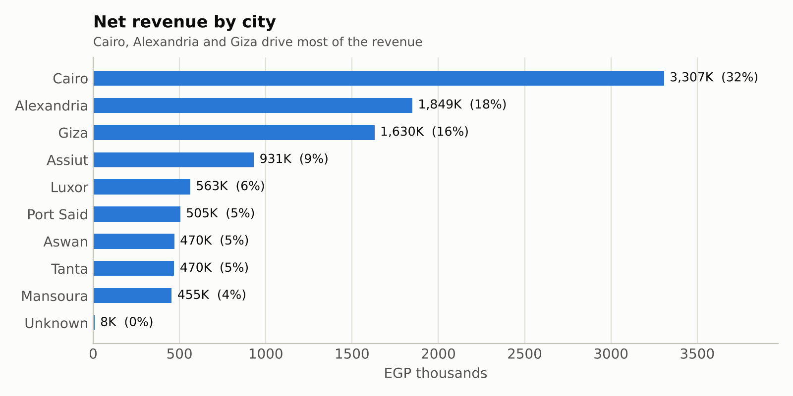
Cairo alone is 32% of net revenue. Cash on delivery is the most used payment method (35% of orders) ahead of credit card (27%). 5% of orders have no recorded payment method, a gap worth closing at the source.

Relationships between variables
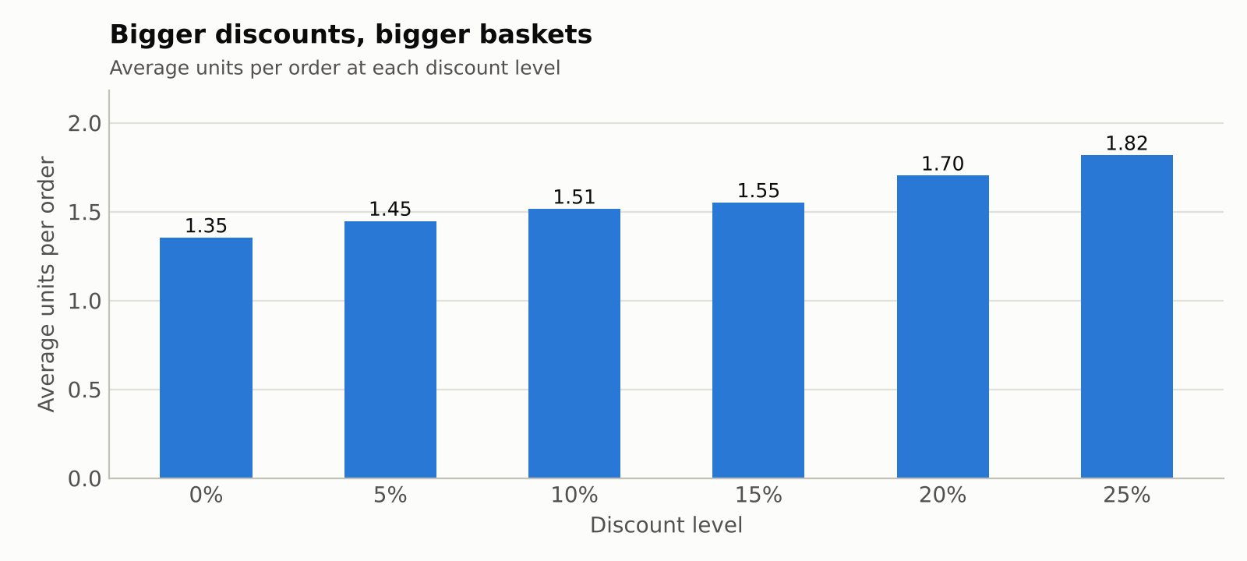
Baskets grow steadily with the discount level, from 1.35 units at 0% to 1.82 at 25% (+34%). But the average order value does not follow: EGP 3,023 without discount against EGP 2,849 at 25% off (−6%). The extra units roughly cancel the price cut, and the correlation between discount and order total is −0.01.
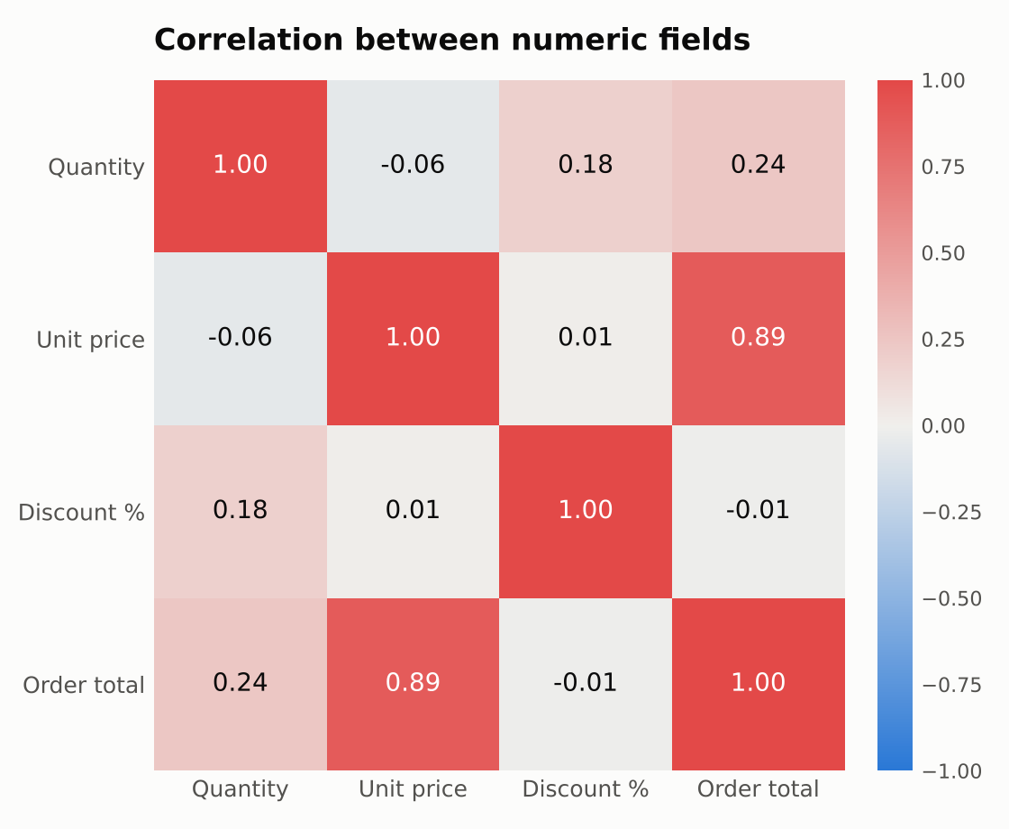
Order total is driven almost entirely by unit price (correlation 0.89), which is why a few high-ticket products dominate revenue. Quantity has a weak positive link with discount (0.18). These are correlations, not proof of cause.

5. Suggested actions
- Investigate Fashion returns. Check size guidance, photos and product descriptions for the items returned most; halving the rate would bring Fashion in line with the other categories.
- Plan for the peaks. Stock and advertising for November (+47%) and March, the two strongest months.
- Make discounts selective. Blanket discounts lift units but not order value. Test them on slow-moving items instead of the best sellers.
- Reduce dependence on two products (Smartphone, Treadmill) and on Cairo by promoting the next-best sellers and the strongest secondary cities.
- Fix data entry at the source. Enforce one date format, numeric-only price and quantity fields, and a mandatory payment method; these three changes would have prevented most of the problems cleaned here.

6. Tools and deliverables
Tools: Python (pandas, NumPy, matplotlib) for cleaning, analysis and charts; Excel formulas, filters and native charts for the workbook.
File | Content
Clean_Sales_Data.xlsx | README, KPI_Summary (live formulas and charts), Clean_Data, Cleaning_Log, Removed_Records
Clean_Sales_Data.csv | The cleaned dataset in CSV form
Raw_Sales_Data_DIRTY.csv | The raw file before cleaning, for before/after comparison
Analysis_Report.docx | This report

